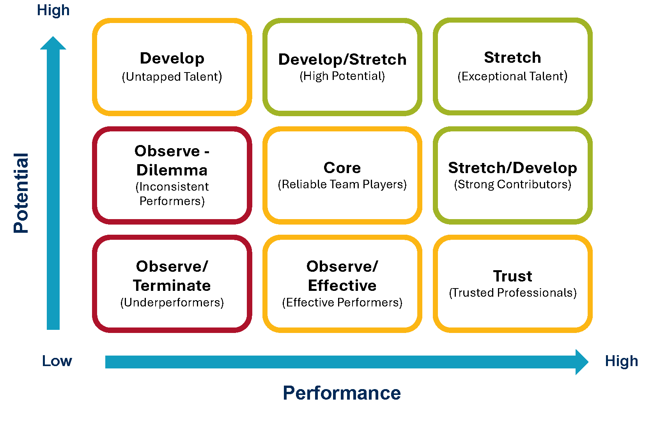

9 Box Grid Template

Performance & Potential | Low  Performance | Moderate  Performance | High  Performance
High  Potential | Develop  Click or tap here to enter text. | Develop/Stretch  Click or tap here to enter text. | Stretch  Click or tap here to enter text.
Moderate Potential | Observe/Dilemma  Click or tap here to enter text. | Core  Click or tap here to enter text. | Stretch/Develop  Click or tap here to enter text.
Low  Potential | Observe/Terminate  Click or tap here to enter text. | Observe/Effective  Click or tap here to enter text. | Trust  Click or tap here to enter text.

